ITU COUNCIL WORKING GROUP
ON INTERNATIONAL INTERNET-RELATED PUBLIC POLICY ISSUES
(CWG-INTERNET)

Online Open Consultations on
“International Internet-Related Public Policy Issues on Harnessing New and Emerging Telecommunications/ICTs for Sustainable Development”
(October 2019-January 2020)
Deadline for submissions: 3rd January 2020

QUESTIONS

Question 1:
How will new and emerging telecommunications/ICTs impact both the internet and sustainable development, including the digital economy?
Answer to question 1: [Add your input in this section]
No doubts new and emerging ICTs not only affect, but determinate our regular life. Just imagine only the one hour or one day without mobile payments, taxi-calling in the pocket, the usual video streaming, etc. Often the case we have problems with internet connection and do you remember how angry you are? The same situation occurs when we talking about developing digital economy, it doesn’t matter what country. In that case questions about cyber resilience, continuity of services and hence the stability of the Internet come to the fore. E-Government, fin-tech, e-transport, e-health – all spheres are vulnerable and need to be protected. So, that is very important side-effect from ICTs and it impact both the internet and sustainable development, including the digital economy.

Question 2:
What are the opportunities and challenges for the adoption and growth of the new and emerging telecommunications/ICTs and internet?
Answer to question 2: [Add your input in this section]
According to my professional area, I will talk about opportunities and challenges in cybersecurity field. Let’s highlight, just for example, 3 emerging technologies, which are actually already among us.
- Artificial intelligence.
There are many ways to use this technology today, including in telecommunications. Starting from customer experience, quality of service and ending software-defined management, biometric authorization. However, what about Deep Fake cases, when hacker can impersonate a legitimate user? This attack also based on artificial intelligence, which can used for illegal purposes.
- Biohacking
Technology allows you to have opportunities «beyond the boundaries of human», also called Do-it-by-yourself. For example, small NFC (or other radio) chip can implanted into your hand without complex surgical intervention, just at home. Ideally, it will not necessary to have credit cards, passes, even passports. With the ubiquitous deployment of eSim technology, you will receive telecom services without anything else except chip in your hand. Nevertheless, the main challenge is how does bank, government or provider actually find out it is really you? Isn’t seem the story about your own body monitoring and control?
- Next-generation infrastructure.
I am talking about 5G, quantum computing, carbon nanotubes, etc. According to 5G, the paradigm of using Internet changes again. Quantity and speed of “connected” computers, personal gadgets, IoT devices will grow dramatically. Especially we are waiting for revolution in M2M communications (Massive Machine-Type Communications, etc.). Besides, hackers could infect devices and use all the benefits and scale deadly of bot-nets to carry out DDOS attacks. Finally, we will figure our DDOS attacks with power more than today’s record 1.7 TBit per second.

Question 3:
How can governments and the other stakeholders harness the benefits of new and emerging telecommunications/ICTs?
Answer to question 3: [Add your input in this section]
Very tricky question and here is why. On the one hand, we have useful technologies, many of which people have become accustomed to. Progress is unstoppable, both citizens and enterprise are already making a profit. As well as the infrastructure in real life cannot exist without control, ICTs must have clear rules of the game too. It is difficult because there is no traditional management in the “Internet planet”. The main task is how to tighten the screws, but not to clamp at all. Therefor many countries, including Russia, start to change their legislation. A non-profit independent regulatory authority (as a Central Bank) could be created as a solution. Representatives of major ICTs companies must be included in it. Not for restrictions, but to prevent chaos and misuse of technology for criminal ways.

Question 4:
What are the best practices for promoting human skills, institutional capacity, innovation and investment for new and emerging telecommunications/ICTs?​​
Answer to question 4: [Add your input in this section]
In my opinion – “where there’s demand, there’s supply”. For example in cybersecurity field, we see staff shortage all over the world. On the other hand, there are many educational initiatives both from institutes and from major companies. This helps to catch up with the delay in this issue. Moreover, ICTs are the driver of economic growth. In addition, it helps to solve real business cases even for traditional companies. For instance, any stakeholder globally has two targets: earn money and safe money. In case of security we had deployment BigData Security Analysis system at a major telecom company. It actually was able to catch employees on fraud using our system. We ended up showing the life result and certain business value. Finally, I believe, only practice makes better. That means real results will provide an opportunity for promoting human skills, institutional capacity, innovation and investment for new and emerging telecommunications/ICTs.

SHORT SUMMARY
[Please provide a short summary (1-3 paragraphs) outlining the main points of your response above]
Talking about new and emerging telecommunications/ICTs I answer with a quote “with great power comes great responsibility”. Technologies provide huge opportunities and positively affect the Internet. The more useful results there are the less need to raise them synthetically. Therefore, practice makes benefits. However, don’t forget about pitfalls. Cybersecurity risks is a greatest challenge. First, we should not be closed, it is necessary to share competences and information about issues between countries and companies. Next, applied Internet or digital technologies must be in accordance with standards and best practices, if there are not – let’s design them. Finally, we, industry definitely have to explain how to use Internet securely. Security awareness activity is very important for both companies and for government. Let’s strictly prohibit the use of technology, even user insists. It's not good practice to shift responsibility, it won't work in the end.

CONTACT DETAILS
- First/Last Name: Roman Zhukov
- Title: Director, Cybersecurity Expert Center
- Country: Russia
- Organization you are representing: Garda Technologies

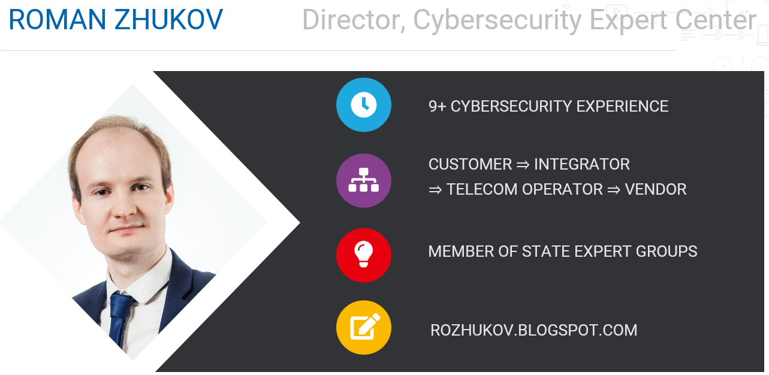
Competence area
- Practicing cybersecurity expert
- Making compliance strategy: licenses, certification, compliance with law, standards
- Actively presenting in the media information field: blog, comments, articles, interviews
- Providing courses and trainings
- Advising customers: cyber security strategy, business value of products, compliance
- Security Development Lifecycle: launch and implementation
- Evangelism, technological and market strategy in the field of cybersecurity
- Participate in GR-, business and technical strategic work groups, community
- Solutions: DDOS protection, Database security, Data leak protection, Security operation center, BigData security analytics, Network security

Feel free to contact me
@ROZhukov
r.zhukov@gardatech.ru

---
Garda Technologies is a Cybersecurity company with experience in developing high-load solutions since 2005. We protect critical systems from cyberattacks and insiders. Our technologies are represented in the major financial companies, industrial and energy corporations, telecom and service providers. Garda Technologies is a part of ICS Holding.

